**System Test Case Specification**

* 1. **Test Case Specification Identifier**

TCS-03-01 2014-05-22

* 1. **Test Items**

Feature test suite **[see *STD-3-2014-06-02 section 3.1*]**.

* 1. **Input Specifications**

The input for this test is generated automatically.

* 1. **Output Specifications**

1. All test packages must execute without failures. The output provided by JUnit ***[see TPS-03-01]*** must match that of figure 1.

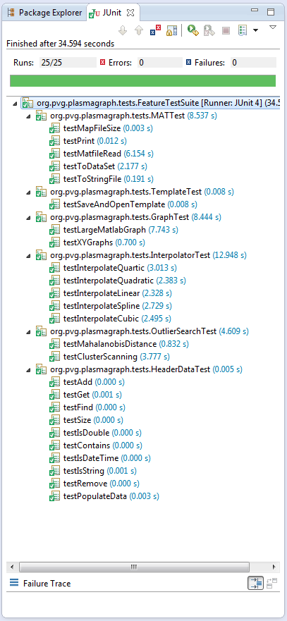

Figure : JUnit expected output

* 1. **Environmental Needs**
  2. **Hardware**

A personal computer with the following minimal specifications is required to execute this case:

* 15’’ Monitor with a resolution of 1200x700 and refresh rate of 30Hz
* A standard alphanumeric American (QWERTY) keyboard
* Two 3.20Ghz microprocessors
* 500Mb of available HDD
* 512Mb of RAM
* One (1) USB 2.0 port
  1. **Software**

PlasmaGraph must be installed in the tester’s computer in order to perform this test case.